FreightDoc AI:

1:- create env and API configuration

used :- Groq API key
Model:- openai/gpt-oss-20b

2:- PDF Processing using PyPDF

Why PyPDF?
We'll use the pypdf library because it allows us to:
- Read PDF files.
- Access individual pages.
- Extract text from each page.
- Handle common PDF processing errors.

Component 3 – Text Chunking and Embeddings
imagine a logistics PDF containing 100 pages and 50,000 words.
If a user asks:
What is the gross weight of the shipment?
We don't want to send the entire 100-page document to the LLM every time.
Instead, we want to:
1. Divide the document into smaller pieces called chunks.
2. Convert each chunk into a numerical representation called an embedding.
3. Later, use these embeddings to find the most relevant chunks when a user asks a question.
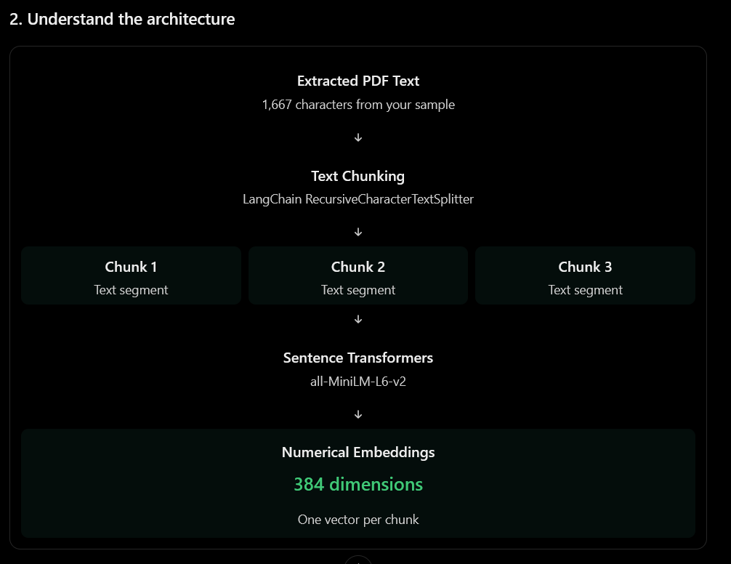
We'll use two libraries:
- LangChain: Splits text into manageable chunks.
- Sentence Transformers: Converts text into numerical vectors.

Two important parameters
Parameter | Meaning | Our setting
chunk_size | Maximum characters per chunk | 800
chunk_overlap | Shared characters between consecutive chunks | 120

RecursiveCharacterTextSplitter
splitter = RecursiveCharacterTextSplitter( chunk_size=800, chunk_overlap=120)
LangChain tries to split text intelligently.
It prioritizes:
- Paragraph boundaries.
- Line boundaries.
- Word boundaries.
- Individual characters when necessary.

Why process every page separately?
Code:- for page in pdf_data["pages"]:
Remember our previous PDF processor?
It returned page-wise information.
We will use that information to retain page numbers in every chunk.
3. What is a LangChain Document?
page_chunks = splitter.create_documents(...)
LangChain creates objects containing two important things:
- page_content: The actual chunk text.
- metadata: Additional information about the chunk.

Embeddings
Important parameters
Parameter | Purpose
SentenceTransformer() | Loads the pretrained embedding model
device="cpu" | Runs inference on CPU
encode() | Converts text into vectors
convert_to_numpy=True | Returns NumPy arrays
normalize_embeddings=True | Normalizes vectors
show_progress_bar=True | Displays embedding progress
The selected model produces 384-dimensional sentence embedding

We chose 384 dimensions because our embedding model, all-MiniLM-L6-v2, is pretrained to generate vectors containing exactly 384 numerical values per text input.

Component 4 – FAISS Vector Database Integration
Why do we need FAISS?
Currently, our application can convert text into numerical vectors.
But where will we store those vectors?
And how will we find the relevant information when a user asks a question?
That's where FAISS comes in.
FAISS (Facebook AI Similarity Search) is a library that helps us efficiently search through numerical vectors and find similar ones.
How does similarity search work?
Let's understand using our shipment example.
User question:
What is the gross weight of the shipment?
FAISS compares the question embedding with the stored document embeddings.
Conceptually:
Chunk | Content | Relevance
Chunk 1 | Shipper and Consignee | Low
Chunk 2 | Cargo and Gross Weight | High
Chunk 3 | Signature and Issue Date | Low
We'll retrieve the top relevant chunks using k.

Understand the important functions
A. create_vector_store()
FAISS.from_documents( documents=documents, embedding=embedding_generator)
This is where our actual vector database is created.
It performs these operations:
- Receives our LangChain document chunks.
- Generates embeddings using Sentence Transformers.
- Creates the FAISS index.
- Associates the original document chunks and their metadata with the vectors.
B. search_similar_chunks()
vector_store.similarity_search_with_score( query, k=k)
This searches the FAISS index and returns:
- Retrieved document.
- Distance score.
We'll retain the score because it will help us understand retrieval quality.
Remember: With our current L2 distance configuration, a smaller score indicates a closer vector match. It is not a probability or percentage.
C. save_vector_store()
Saves the index and associated document information locally.
D. load_vector_store()
Loads a previously saved index.
Security note: allow_dangerous_deserialization=True can load pickle-backed data. Only load indexes you created yourself or otherwise trust. We won't need to load arbitrary user-provided FAISS files.

Component 5 – RAG-Based Question Answering
Understand the RAG architecture
RAG stands for Retrieval-Augmented Generation.
It combines two major operations:
- Retrieval: Finding relevant information from the document.
- Generation: Using an LLM to generate an answer based on that information.
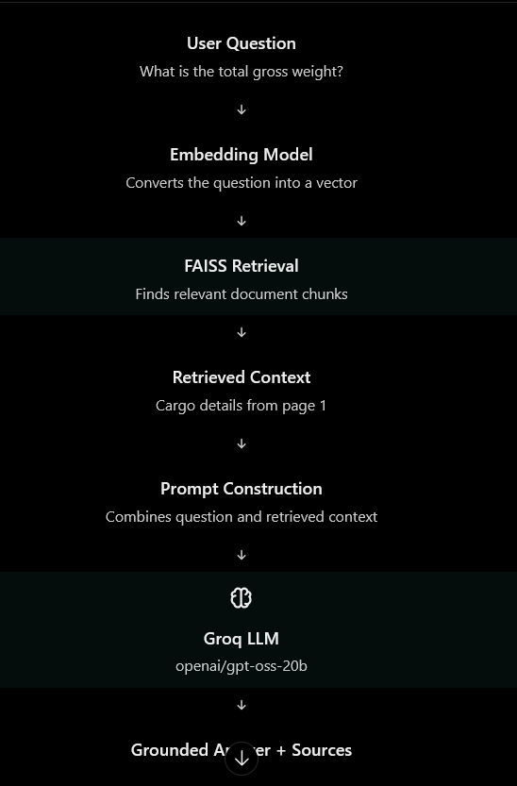

Why langchain-groq?
It provides the ChatGroq class, which connects LangChain prompts and chains to Groq's hosted language model

We'll continue using: model name
openai/gpt-oss-20b

Understand prompt engineering :
Understand prompt engineering before coding
This is an important part of RAG.
Imagine FAISS retrieves this information:
Port of Loading: Long Beach, USA
Port of Discharge: Sydney, Australia
Total Gross Weight: 6,300 KG
We need to send this context to the LLM along with the user's question.
We'll use a prompt with three sections:
System instruction:
You are FreightDoc AI.
Answer questions using only the provided document context.
Do not invent information.
If the answer is not present in the context,
clearly state that it was not found.
Retrieved context:
[Source 1 | bill-of-lading.pdf | Page 1]

Port of Loading: Long Beach, USA
Port of Discharge: Sydney, Australia
Total Gross Weight: 6,300 KG
User question:
What is the total gross weight?
The LLM receives all three together and generates an answer.
This is called context augmentation.
One more important rule: the uploaded document is data, not an instruction source. If the PDF contains text telling the AI to ignore its instructions, our prompt will explicitly tell the model to ignore such embedded instructions.

Understand the RAG code
Let's understand the four main operations.
A. Initialize the LLM
llm = ChatGroq( model=GROQ_MODEL, temperature=0.1, max_retries=2)
This initializes our Groq language model.
- model: Reads the model name from .env.
- temperature: Controls response variability.
- max_retries: Retries failed requests.
B. Retrieve relevant chunks
results = vector_store.similarity_search_with_score( question, k=3)
This is the retrieval stage.
It converts the question into an embedding and searches FAISS.
The result contains document chunks and their distance scores.
C. Construct context
context = "\n\n".join(context_parts)
We combine the retrieved chunks into one context string.
We also attach source markers and page numbers so the LLM can reference the correct document sections.
D. Generate the answer
answer = rag_chain.invoke({ "context": context, "question": question})
This is the generation stage.
The chain performs:
Prompt Template → Groq LLM → String Output Parser
The output parser extracts the model's textual answer.
Important: The LLM does not directly search FAISS. Our Python code retrieves the chunks first and then passes them to the LLM.

